Formula Sheet (All notations/symbols are standard, note that not all information is relevant)

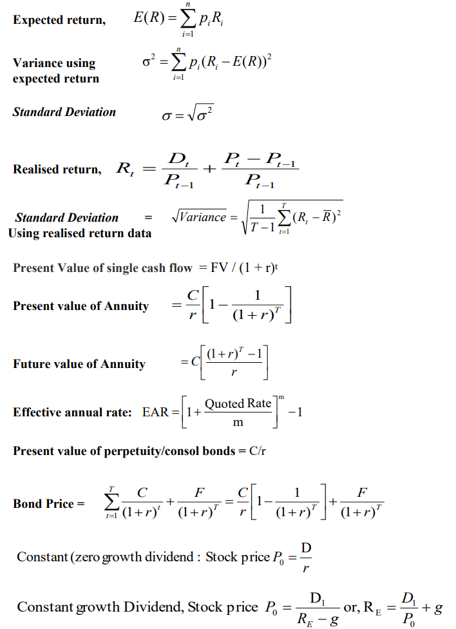

Formula Sheet (continued):
Present value of a growing perpetuity : $\frac{C}{r-g}$
Present value of a growing annuity: $\frac{C}{r-g}$(1-$({\frac{1+g}{1+r})}^{ N})$
Operating Cash Flow (CFO) = Net Income+Depreciation-$\text{∆}\text{NWC}$
Free Cash Flow = CFO– CapEx + After tax interest or
Free Cash Flow = Unlevered Net Income +Depreciation – CapEx-$\text{∆}\text{NWC}$

In equilibrium: $\frac{E\left(R_{A}\right)-R_{f}}{β_{A}}=\frac{E\left(R_{M}\right)-R_{f}}{β_{M}}$
The formula of SML using CAPM: $E\left(R_{A}\right)=R_{f}+β_{A}(E\left(R_{M}\right)-R_{f})$
WACC = $w_{E}×R_{E}+w_{D}×R_{D}×(1-tax rate)$

Formula Sheet of Excel:
Payment per period: PMT (rate,nper,pv,[fv],[type])
Present value: PV (rate, nper, pmt,[fv],[type])
Future value: FV (rate, nper, [pmt], [pv], [type])
Number of payment: NPER (rate, pmt, pv, [fv], [type])
Net Present Value: NPV (rate, value1, value 2,…)
Internal rate of return: IRR(value 1, value 2,.)

